Guide to Raising Chickens
House/ Coup Plans- Birds should be kept in a controlled environment at all times. Temperature in your House/Coup should not vary more than few degrees at chicken level. Each Bird needs approximately one square foot of space each, if you have 25 birds you should have at minimum a 10ft X10ft space to keep them in. Chickens are like fish they will grow in accordance to the size space that you keep them in hence the more space they have the bigger they will get. On the down side the bigger the space the harder it is to control the temperature. The pen should also be able to be divided in half due to the need to separate males and females. Pens should also have adequate ventilation, to allow for fresh air to come in and bad air to go out. Chickens create A LOT of ammonia smell, and this needs to be ventilated out either through exhaust fans, or open air spaces. Ammonia smell can/will stunt the growth of birds. Shavings also need to be changed regularly. If you have a ground coup it is recommended that you add a layer of sand underneath your shavings, this allows for proper drainage, as well as keeping the ammonia smell down. Elevated coups such as wire cages I would recommend that you place a wood floor in your coup and build up the sides of the wood with a 2X4 or 1X4 to keep the shavings from falling through and prevent the chickens from sliding around on the shavings. Another thing to keep in mind is the size of the opening in your coup, chicks will be small when they go in, but if you do your job right they will be large coming out and the opening needs to be at least 2 ft X 2 ft to get them out without taking a chance at breaking a wing, or bruising them.
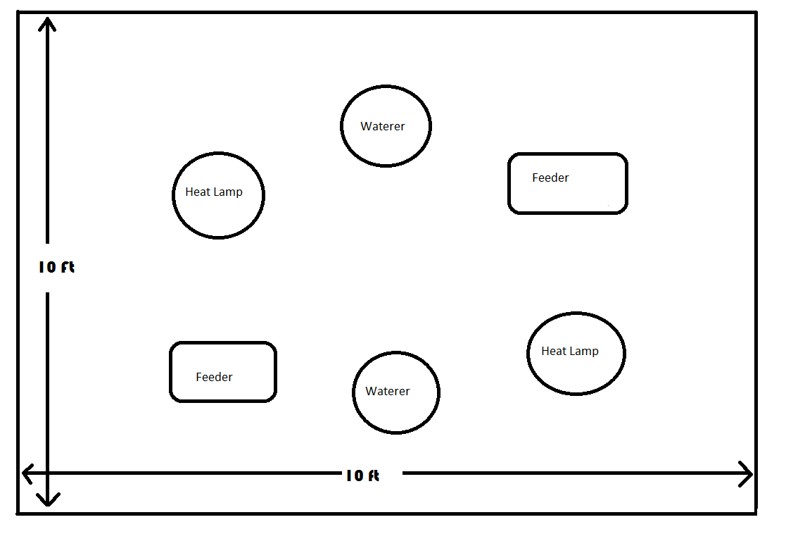
Equipment List: Have all this available before you pick up your birds
Feeders/ Waterers- Need at least 2-3 large ones of each per 25 birds. Also need to be able to elevate them as chickens grow with blocks, or hanging.
Heat Lamps- need to have enough to maintain the proper temperatures for the space you have. Larger spaces need more heat lamps.
Clean Sheets- Need a few old sheets free of holes
Thermometer- have at least one thermometer kept at chicken level so you know what their temperature is.
2 of Dozen Boiled Eggs
Vitamin B Complex
1 of package of electrolytes
Fans- can be used as exhaust fans, or turned inwards to be used for cooling I like to use square fans that you can put in a window opening so you can turn them around and face them either way for what you need.
Turkey Starter- Need one bag of show quality turkey starter. You need to feed one bag of turkey starter to start with and then switch to a show quality chicken grower when they have eaten the entire bag of turkey starter.
Shavings- have a 2-3 of bags to start with
Temperature Control: Birds should be maintained at certain temperatures to allow for optimum growth. Birds should be kept at 95 degrees on the first day you get them, and temperature should be lowered one degree a day until you reach 68 degrees and then they need to stay at 68 degrees until the show. It is a good practice to create different temperature zones in your house for those birds to move to by hanging heat lamps at different levels, but these zones should not vary more than a few degrees from what your daily temperature should be. Chickens will tell you if they are at the right temperature. If all the chickens are evenly spaced throughout the house the temperature is just right. If they are all huddled under the heat lamps the temperature is too cold. If they are all along the sides and as far away from the heat lamps as they can get, they are too hot.

Feeding Birds: There are as many schools of thought in feeding as there are chicken raisers out there. One thing that is in common with almost all feeding programs is the use of Turkey Starter to start show birds off with. I would start with one bag of Turkey Starter per 25 birds (if you have 50 birds use 2 bags of turkey starter) and feed it until it is gone and then switch over to a Chicken Grower. Some people feed chicken grower all the way until the show, and some people switch over to a chicken finisher at some point. That point varies in ideas: some people switch to finisher one week after the birds have fully feather out, and some people switch 7 days before the show, and some people never switch from the chicken grower. Whichever method you choose is fine. The main thing is that birds have fresh feed and adequate access to feed at all times. If you run out of feed in your feeders then your chickens stop growing, plain and simple. You need to have enough feeders that every chicken can get to feed when it wants it.
Watering Birds: On the first three days the birds need to be drinking a mixture of water electrolytes, and vitamin B. Mix one gallon of electrolyte solution in accordance to the directions on the electrolytes you purchase then add 3 CC of Vitamin B to that solution and mix well. This is for the first three days ONLY. Electrolytes can be added to the chicken’s water at various times throughout the feeding period, but you need to be sure not to overdo it because this will cause problems with the chickens feet and legs and they will not be able to get up and get to feed. Most chicken feeders only use electrolytes when chickens seem to not be eating well, and then only for a day or two per week. Finally you need to use electrolytes on the last 3 days before the show. The most important thing about water is that it is fresh, cool and readily available.
Starting Procedures:
Clean out your chicken house and spray with a solution of 1 cup of bleach to one gallon of water to sterilize the house a couple of days before birds arrive and let it air out.
Brooder area: You can use your divider board for separating males and females to make a smaller area to start your chicken in then remove it later as they require more room. This will allow you to use less heat lamps, and save on the electric bill.
1 day prior to bird arrival- Using heating methods (Heat Lamps, Heaters Etc.) Bring the thermometer at chicken level to 95 degrees and spread out sheet for the chickens to start on. Mix solution for watering birds and put in refrigerator. Boil a couple of dozen eggs and put in the refrigerator
Bird Arrival Day/ First Three Days: The quicker you pick up your birds the quicker they are eating and drinking (growing) before the competitions. Have your feeders and waterers full before birds arrive in your house. When you get there with the birds take 3-6 boiled eggs and peel them out of the shell and crumple the boiled eggs up into fine pieces and sprinkle over the turkey starter. Take each bird out of the box and show him where the water is by placing its beak in the water and then do the same for the feed. Birds should begin to eat and drink immediately from there. You need to check on birds often (like every couple of hours) during the first couple of days due to their need for a heat source if a bulb burns out or gets unplugged you could lose valuable growing time, as well as get birds sick. Continue to sprinkle eggs on feed in the morning and at night for the first 48 hours. By the morning of Day 3 you should be done with your 2 dozen eggs, and should not have to add them again. The afternoon of Day 3 you should remove the sheets and add shavings.
Stirring Birds: A chicken’s digestive tract runs on an approximately 1 hour 30 min cycle of needing to be refilled. Chickens are naturally lazy animals and will not get up that often to eat and drink. Many chicken raisers go into their houses every hour or two and walk around to stir their birds, or they put a radio, or lights on a timer that goes off and on every hour or two. I would recommend that when you are home making this a habit to stir your birds in some method every hour or two.
Shavings: Shavings need to be changed frequently to prevent build up of ammonia in the air that chickens breathe. If you would not put your face next to the shavings and take a big sniff then why would you expect your chickens to breathe that bad air every breath they take. A good way to test if the shaving need to be changed is to bend over and smell at chicken level if it stinks then you need to change shavings. Shavings need to be stirred every day and changed at least once a week if not more. A good leaf rake works well for this. Watch out for chickens when you do this!!!!
Culling Birds: During the raising process you will need to remove birds that are under-performing, or that are sick. If you notice a bird that is sickly looking it should be removed at once to prevent the other birds from getting sick as well. I would not suggest keeping the sick ones anywhere near your pen of birds. After the first three weeks you, with the help of your Ag Teacher should go in and separate out the males and females and at this time should remove any birds that are under-performing and not growing as well as the other birds. You either need to have a separate pen for the cull birds, or have arrangements made for the birds to go somewhere else.
Show Preparations: Three days prior to show you need to put your chickens back on an electrolyte mix in their water. This helps boost the chicken’s brain function and increases water retention in the muscle to give your birds that full hard feel. You will also need to select your top 4-5 birds that you will be taking to the show. Always remember to take at least one extra bird other than your top three in case something happens to one of your birds on the way to the show. Your Ag Teacher will be available to help you select your top five birds a few days prior to show day.

BEST OF LUCK TO ALL OF YOU!!!!!

